**COGNIZANT DIGITAL NURTURE PROGRAM 4.0**

**JAVA FSE DEEP SKILLING**

**SUPERSET ID : 6391159**

**NAME : SATHYA SHREE R**

**CLASS : ECE C**

**REG NO : 727822TUEC207**

**WEEK 5 HANDS ON EXERCISE – Microservices with Spring Boot 3 and Spring Cloud**

**Exercise : Creating Microservices for account and loan**

**Microservices with API gateway**

**PROBLEM STATEMENT :**

Design and implement two independent Spring Boot microservices for a bank—**Account Service** and **Loan Service**—each exposing a REST API to retrieve dummy account or loan details based on a given account number. Ensure both services run on different ports to simulate real microservice deployment environments.

**CODE :**

* **ACCOUNTS**

**AccountApplication.java**

package com.cognizant.account;

import org.springframework.boot.SpringApplication;

import org.springframework.boot.autoconfigure.SpringBootApplication;

*@SpringBootApplication*

public class AccountApplication {

public static void main(String[] args) {

SpringApplication.*run*(AccountApplication.class, args);

}

}

**AccountController.java**

package com.cognizant.account;

import org.springframework.web.bind.annotation.*;

*@RestController*

*@RequestMapping*("/accounts")

public class AccountController {

*@GetMapping*("/{number}")

public Account getAccount(*@PathVariable* String number) {

return new Account(number, "savings", 234343);

}

static class Account {

private String number;

private String type;

private double balance;

public Account(String number, String type, double balance) {

this.number = number;

this.type = type;

this.balance = balance;

}

// Getters

public String getNumber() { return number; }

public String getType() { return type; }

public double getBalance() { return balance; }

}

}

**application.properties**

spring.application.name=account

server.port=8081

spring.application.name=account-service

eureka.client.service-url.defaultZone=http://localhost:8761/eureka

**pom.xml**

<?xml version="1.0" encoding="UTF-8"?>

<project xmlns="http://maven.apache.org/POM/4.0.0" xmlns:xsi="http://www.w3.org/2001/XMLSchema-instance"

xsi:schemaLocation="http://maven.apache.org/POM/4.0.0 https://maven.apache.org/xsd/maven-4.0.0.xsd">

<modelVersion>4.0.0</modelVersion>

<parent>

<groupId>org.springframework.boot</groupId>

<artifactId>spring-boot-starter-parent</artifactId>

<version>3.5.3</version>

<relativePath/> <!-- lookup parent from repository -->

</parent>

<groupId>com.cognizant</groupId>

<artifactId>account</artifactId>

<version>0.0.1-SNAPSHOT</version>

<name>account</name>

<description>Demo project for Spring Boot</description>

<url/>

<licenses>

<license/>

</licenses>

<developers>

<developer/>

</developers>

<scm>

<connection/>

<developerConnection/>

<tag/>

<url/>

</scm>

<properties>

<java.version>17</java.version>

</properties>

<dependencies>

<dependency>

<groupId>org.springframework.boot</groupId>

<artifactId>spring-boot-starter-web</artifactId>

</dependency>

<dependency>

<groupId>org.springframework.boot</groupId>

<artifactId>spring-boot-devtools</artifactId>

<scope>runtime</scope>

<optional>true</optional>

</dependency>

<dependency>

<groupId>org.springframework.boot</groupId>

<artifactId>spring-boot-starter-test</artifactId>

<scope>test</scope>

</dependency>

</dependencies>

<build>

<plugins>

<plugin>

<groupId>org.springframework.boot</groupId>

<artifactId>spring-boot-maven-plugin</artifactId>

</plugin>

</plugins>

</build>

</project>

* **LOANS**

**LoanApplication.java**

package com.cognizant.loan;

import org.springframework.boot.SpringApplication;

import org.springframework.boot.autoconfigure.SpringBootApplication;

@SpringBootApplication

public class LoanApplication {

    public static void main(String[] args) {

        SpringApplication.run(LoanApplication.class, args);

    }

}

**LoanController.java**

package com.cognizant.loan;

import org.springframework.web.bind.annotation.*;

*@RestController*

*@RequestMapping*("/loans")

public class LoanController {

*@GetMapping*("/{number}")

public Loan getLoan(*@PathVariable* String number) {

return new Loan(number, "car", 400000, 3258, 18);

}

static class Loan {

private String number;

private String type;

private double loan;

private int emi;

private int tenure;

public Loan(String number, String type, double loan, int emi, int tenure) {

this.number = number;

this.type = type;

this.loan = loan;

this.emi = emi;

this.tenure = tenure;

}

// Getters

public String getNumber() { return number; }

public String getType() { return type; }

public double getLoan() { return loan; }

public int getEmi() { return emi; }

public int getTenure() { return tenure; }

}

}

**application.properties**

spring.application.name=loan

server.port=8081

**pom.xml**

<?xml version="1.0" encoding="UTF-8"?>

<project xmlns="http://maven.apache.org/POM/4.0.0" xmlns:xsi="http://www.w3.org/2001/XMLSchema-instance"

xsi:schemaLocation="http://maven.apache.org/POM/4.0.0 https://maven.apache.org/xsd/maven-4.0.0.xsd">

<modelVersion>4.0.0</modelVersion>

<parent>

<groupId>org.springframework.boot</groupId>

<artifactId>spring-boot-starter-parent</artifactId>

<version>3.5.3</version>

<relativePath/> <!-- lookup parent from repository -->

</parent>

<groupId>com.cognizant</groupId>

<artifactId>loan</artifactId>

<version>0.0.1-SNAPSHOT</version>

<name>loan</name>

<description>Demo project for Spring Boot</description>

<url/>

<licenses>

<license/>

</licenses>

<developers>

<developer/>

</developers>

<scm>

<connection/>

<developerConnection/>

<tag/>

<url/>

</scm>

<properties>

<java.version>17</java.version>

</properties>

<dependencies>

<dependency>

<groupId>org.springframework.boot</groupId>

<artifactId>spring-boot-starter-web</artifactId>

</dependency>

<dependency>

<groupId>org.springframework.boot</groupId>

<artifactId>spring-boot-devtools</artifactId>

<scope>runtime</scope>

<optional>true</optional>

</dependency>

<dependency>

<groupId>org.springframework.boot</groupId>

<artifactId>spring-boot-starter-test</artifactId>

<scope>test</scope>

</dependency>

</dependencies>

<build>

<plugins>

<plugin>

<groupId>org.springframework.boot</groupId>

<artifactId>spring-boot-maven-plugin</artifactId>

</plugin>

</plugins>

</build>

</project>

**OUTPUT :**

**accounts**

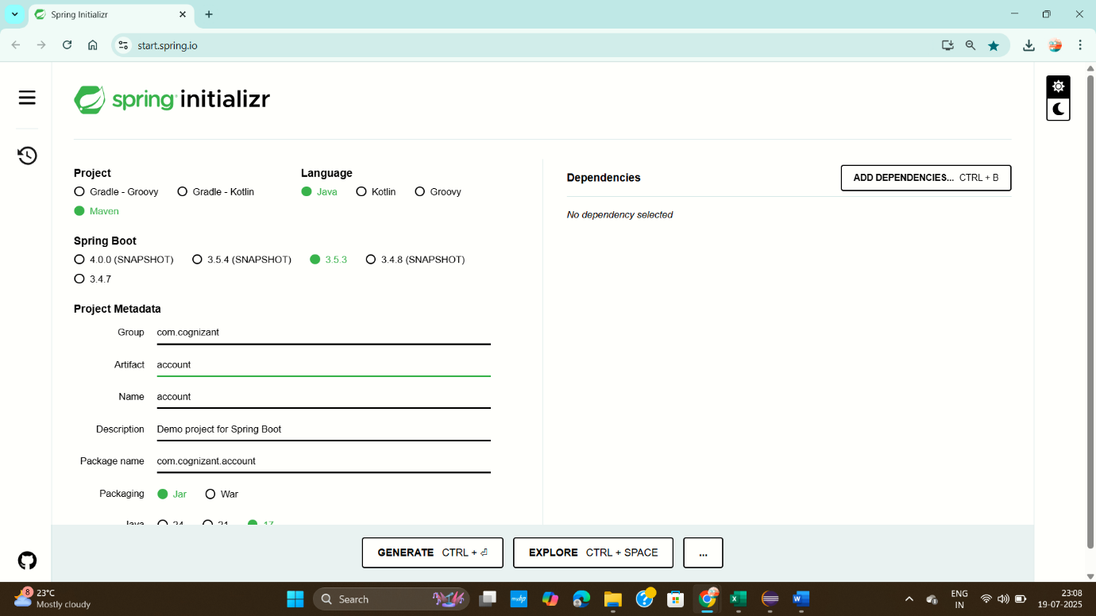

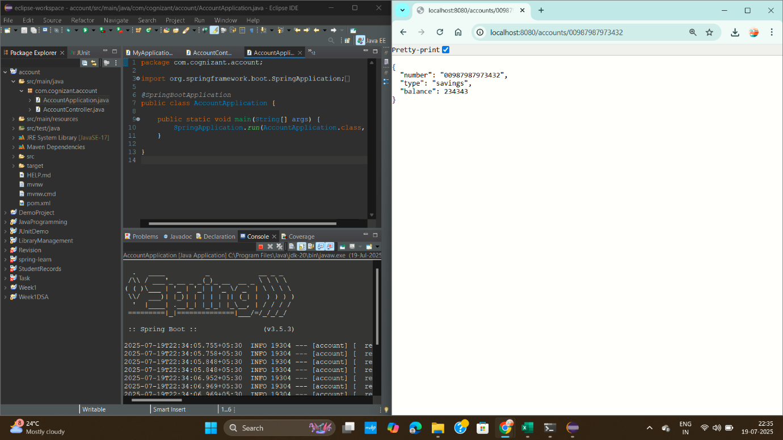

**loans**



